Exercise 1: Build a simple neural network to predict breast cancer.

Introduction: Breast cancer prediction is a task which you try to predict whether a person’s cancer status is benign or malignant based on 30 given features

Step 1: Load data:

* Use sklearn to load breast cancer data (if you don’t know, please google :)) )
* Extract data (features) and target (label)
* Print shape of data and target

Step 2: Explore data:

* Print max, min and mean value of each feature in data (Purpose: See the data range)
* Print number of samples having label = 0 (benign) and number of samples having label = 1 (malignant)
* Use matplotlibs to draw the barplot represent the number of each class as the following

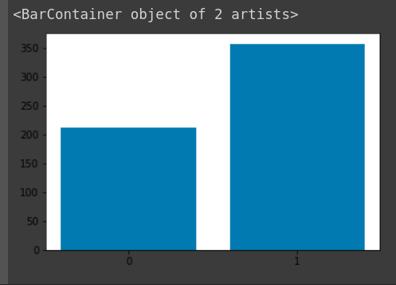

Step 3: Normalize data

* Divide each feature column of data by its max value

Step 4: Split train, and validation: Use sklearn train_test_split module to split data to x_train, y_train, x_val, y_val

Step 4: Define model:

* Follow this architecture:

Sequential model

Dense, units = 10, activation=’relu’

Dense, units = 2, activation=’sigmoid’

* Compile model:

Loss = ‘binary_crossentropy’

Optimizer = ‘rmsprop’

Metrics = ‘accuracy’

Step 5: Training:

* Fit x_train, y_train to model
* Train on 20 epochs or more with batch size = 64
* Your accuracy should be higher than 0.9

Step 6: Evaluate on validation data:

* Use model.evaluate()
* Print accuracy and loss on validation data

Step 7: Make prediction on validation data:

* Use model.predict() on x_val to get y_prediction which has shape = y_val. The output is the probability of binary classification.
* Use threshold = 0.5 to get the label_prediction (prob >= 0.5 -> 1, prob <= 0.5 -> 0). Label_prediction will have the same shape as y_val and y_prediction